Discussion of Results

The figure below presents a snapshot of total implemented CDR capacity by mode of sequestration across the nineteen regions examined, Average sequestration capacities for each CDR technology were calculated across all scenarios for a given country, then summed across all examined spatial contexts. The results indicate that BECCS remains the most prominent and heavily deployed method of carbon removal across different IAMs, accounting for around two thirds of ‘global’ sequestration capacity in 2100. These findings are in line with other reviews, which have found that BECCS dominates among CDR technologies in IAMs, and that models opt for delayed-action carbon removal over emissions reductions due to predominant use of high discount rates (Köberle, 2019). DAC shows substantial growth through the end of the century, implying technological learning curve advancements that make it more economically feasible (Young et al., 2022), increasing acceptance of its adoption as a viable alternative, and the deployment of incentives and direct investments to scale up its implementation (Mace et al., 2021). Furthermore, non-negligible DAC deployment begins to materialize around 2040, confirming that global trends align with our Canada-specific analysis using the Navius database. Land-based CDR methods, such as afforestation and reforestation, grow at the slowest pace before shrinking slightly towards the end of the century across most spatial contexts. Overlapping requirements and constraints related to food production, biodiversity conservation, and urban development limit the scalability of these nature-based approaches. Further details on country-specific scenarios and emissions and sequestration trends can be found in SI Appendix 5.
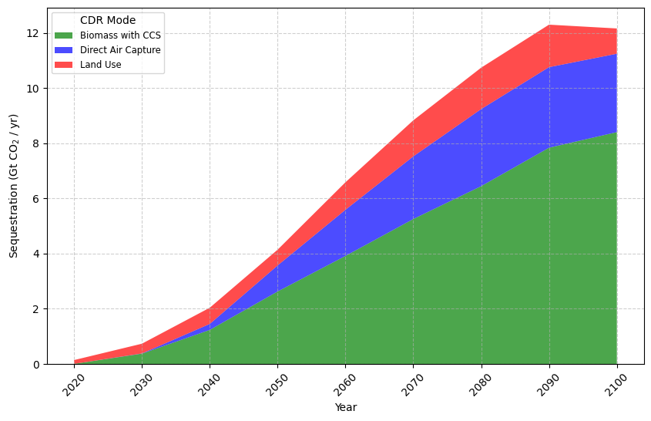

Total Mean Implemented CDR Capacity by Mode of Sequestration. This stacked area plot presents total average projected CDR implementation across the 19 national spatial contexts extracted from the CD-Links database. Three CDR modes are represented in the analysis: BECCS, DAC, and land use. The negative emissions are tracked from 2020 to 2100 in ten-year intervals and in units of Gt CO₂ of annual sequestration.

References

Köberle, A. C. (2019). The Value of BECCS in IAMs: A Review. Current Sustainable/Renewable Energy Reports, 6(4), 107–115. https://doi.org/10.1007/s40518-019-00142-3

Mace, M. J., Fyson, C. L., Schaeffer, M., & Hare, W. L. (2021). Large‐Scale Carbon Dioxide Removal to Meet the 1.5°C Limit: Key Governance Gaps, Challenges and Priority Responses. Global Policy, 12(S1), 67–81. https://doi.org/10.1111/1758-5899.12921

Young, J., McQueen, N., Charalambous, C., Foteinis, S., Hawrot, O., Ojeda, M., Pilorgé, H., Andresen, J., Psarras, P., Renforth, P., Garcia, S., & van der Spek, M. (2022, November). The cost of direct air capture and storage can be reduced via strategic deployment but is unlikely to fall below stated cost targets (Version 3). ChemRxiv. https://doi.org/10.26434/chemrxiv-2022-dp36t-v3

